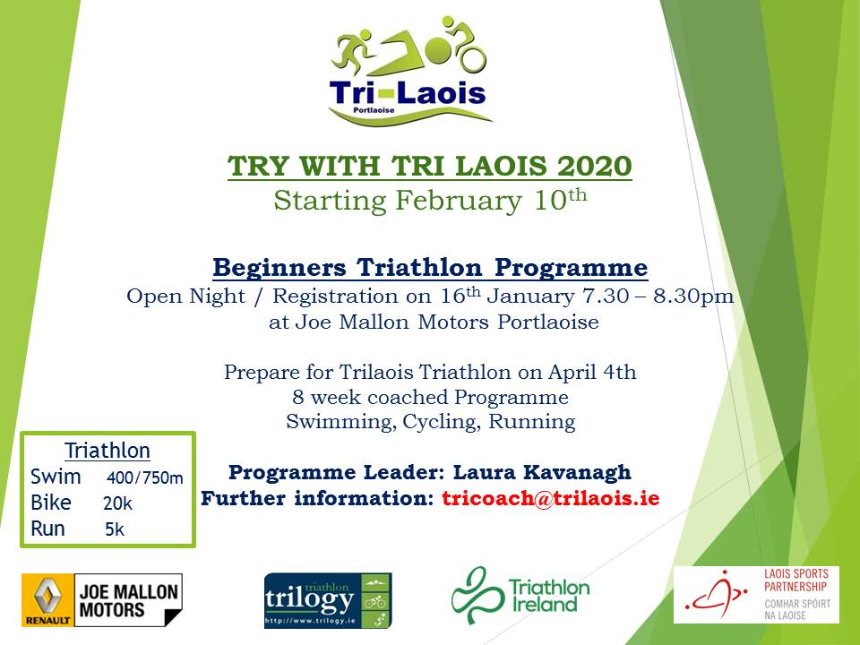

About the Programme
- This is an 8 week coached programme for men and women coached by Triathlon Ireland certified coaches and Trilogy Triathlon Club leaders
- Places are strictly limited to 21 participants and will be allocated on a first paid basis
- Over the 8 weeks participants will get the chance to take part in over 24 training sessions including running, swimming, cycling and participation in a duathlon and a pre-race triathlon
- By 4th April you will be equipped to complete the TriLaois Try Race – 400m/750m Swim – 20km Cycle – 5km run

Participant Conditions
- You must be living in Laois and be over 18 years old
- You must become a member of Triathlon Ireland in order to be insured for training and partaking in TI sanctioned and Trilogy Triathlon Club races

Costs
- The cost of the programme is €60 and must be paid before 10th February to ensure your place.
- Other costs and information re Triathlon Ireland membership fees are detailed below

Swim

- Participants must be able to swim at least 25 metres non-stop
- Wednesday, 8-9pm at Portlaoise Leisure Centre (PLC)
- Bring hat, goggles, water bottle, swimsuit
- Coach: Eimear Matthews
- All participants are encouraged to do additional swimming practice

Cycle

- Must have a roadworthy road bike – no mountain bikes
- Saturday 10am (duration 60-90 mins) - meet at Centrepoint, Mountrath Road
- Must carry a mobile phone and spare tube on all cycles
- Must wear a helmet, hi-vis and appropriate clothing for weather (rain gear, etc)
- Coach: Denise Murphy

Run

- Monday 7-8pm meet at the back of Portlaoise Leisure Centre beside the field
- Wear runners, hi-vis, weather appropriate clothing, bring water
- Coach: Denise Murphy

Everything Else You need to Know:

- We will have transition preparation sessions, i.e. how to go from Swim to Bike to Run efficiently
- We will be holding two club events to prepare you for TriLaois
- One is a Duathlon in March (Run/ Bike/ Run). Location- The Heath
- The other is a club Triathlon on March 28th – you will have the opportunity to do a trial run with our club members before the big day, location: PLC
- WhatsApp is our main method of communicating with participants. Please download so you can be included in group and kept up to date of all training sessions
- Race Entry is open on Triathlon Ireland website.

Triathlon Ireland Licence
- This licence is mandatory and is your insurance to participate in triathlon and to participate in training with Trilogy Triathlon.
- It is not a membership fee for Trilogy Triathlon Club
- Your TI licence is a fee payable to Triathlon Ireland in order to participate in the sport of triathlon

Information re Triathlon Ireland Licence – PLEASE READ CAREFULLY as this will explain which type of licence you should buy. This information is available on the Triathlon Ireland website

MEMBERSHIP TYPES & FEES FOR 2020
The cost of membership with Triathlon Ireland varies depending on whether you are a triathlon club member or not. Explanations for each membership type are given below.
Membership Type | Club Member | Non-Club Member
Race Licence | €66 | €75
Training Licence | €23 | €25
ODM – One Day Membership | €22 | €25

2020 RACE LICENCE: €66 (NON-CLUB MEMBER: €75)
Suitable for those who intend to race in 2020. You receive a level of personal accident cover, are insured for training with a club and to participate in as many Triathlon Ireland sanctioned events as you wish to enter, without paying a One Day Membership fee.
Becoming a race licence member of Triathlon Ireland is easy and comes with many benefits
- Insurance Cover - Third party and personal accident cover while racing in a sanctioned event, training with an affiliated club or training on your own.
- Annual Race Licence - Avoid the need to purchase a One Day Membership for each event.
- Race Series Eligibility - Compete in any of the Triathlon Ireland Race Series.
2020 TRAINING LICENCE
- Training Licence/Non Racing Licence Members are not covered for racing and they must pay a One Day Membership fee to participate in a TI sanctioned race.
- Insurance Cover - Third party and personal accident cover during training with an affiliated club

ONE DAY MEMBERSHIP
The one day membership (ODM) fees apply to all participants who are not current Triathlon Ireland annual members.
Insurance Cover - Third party and personal accident cover while racing in a sanctioned event through Triathlon Ireland.
One Day Membership Fees:
- Triathlon - €25
- Try-a-Tri - €15

Summary re Licence

- If you think you will race in more than one triathlon during 2020 it is better to get a racing licence

- If you will only race in one triathlon, you will need to purchase a training licence and a one day membership licence, for the one race you will participate in e.g. TriLaois.

How to buy a Licence
- Log on to www.triathlon Ireland.ie
- Click “Members Log in” and select “Register Here” at the bottom
- Once you register, you’ll be taken to your profile – select Membership/Renew Membership
- Select the type of licence you would like.

*Please note a discount will be applied if you select Trilogy Triathlon Club as your Club and the price should update to the discounted rate.

