Glute Activation

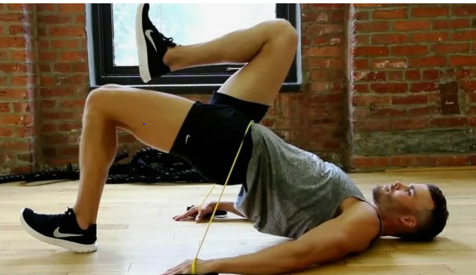

- Engage core
- Squeeze glutes
- If you don’t have a round band don’t worry just do single leg
- Repeat 3 times each side
- Slow and controlled
- Same technique as the double leg bridge

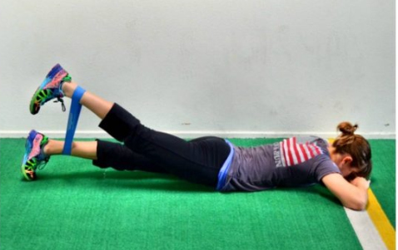

- Begin lying face down on the floor, your band looped around your ankles.
- Lift one flexed foot toward the ceiling, engaging your glutes against the band resistance.
- Avoid arching your back and turning your feet.
- Repeat for 10 to 15 reps, then switch legs.

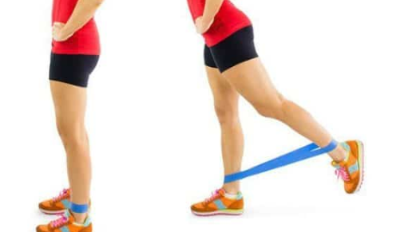
Stand facing a wall of chair for balance. Loop your band just above your ankles.
Keeping your leg straight and flexing your right foot, extend it behind you, squeezing your glute to lift your leg (don’t rock forward to get your leg higher).
Pause for a beat during your extensive, then lower slowly.
Repeat on both legs for 10 to 15 reps.

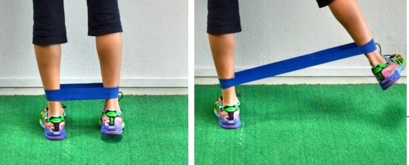
- Begin standing, wrapping your mini band around your legs just above your ankles. You can face a chair or a wall to help you keep your balance.
- Lift your right leg out to your side, flexing your foot and keeping your toes pointing forward.
- Repeat for 10 to 15 reps on each leg, maintaining tension in the band throughout each rep

Hamstring flexibility
- Sit on the floor with both legs out straight.
- Extend your arms and reach forward by bending at the waist as far as possible while keeping your knees straight.
- Hold this position for 15 to 30 seconds.
- Relax back into the starting position.
- Repeat three times.
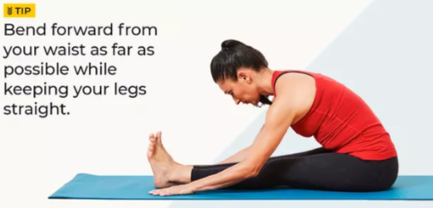
- Sit on the floor with one leg out straight.
- Bend the other leg at the knee and position the sole of that foot against your opposite inner thigh.
- Extend your arms and reach forward over the one straight leg by bending at the waist as far as possible.
- Hold this position for 10 seconds.
- Relax.
- Repeat with the other leg.
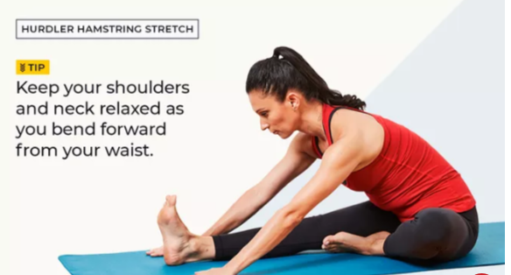

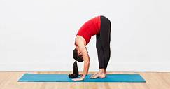
- stand and cross your right foot in front of your left.
- Slowly lower your forehead to your right knee by bending at the waist.
- Keep both knees straight.
- Hold this position for 15 to 30 seconds.
- Relax.
- Repeat for the other side by crossing your left foot in front of your right.

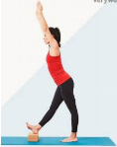
- Stand up straight with one heel resting on a small stack of books or stool. If you are outside, you can use the curb, but be sure to watch for cars.
- Keep your knee straight.
- Reach both arms up toward the place where the wall and ceiling meet. If you are outside and there is no wall or ceiling, simply reach up into the air so your arms are about even with your ears. Reaching your arms up, as opposed to reaching down toward your foot, will keep your back straight.
- Keep your back straight. You should be bending forward slightly from your hips.
- Reach forward and feel a stretch in your hamstring behind your thigh.
- Hold the stretch for 15 to 30 seconds, and repeat three times.
- Switch legs and repeat with the other leg.

- Lie on the floor on your back.
- Loop a long bath towel around your toes and hold the ends of the towel in both hands.
- Slowly pull on the towel to lift your straight leg up. Be sure to keep your knee straight. The leg without the towel should remain flat on the ground.
- Bring your leg up until a stretch is felt behind your thigh. You may also feel a stretch behind your lower leg in your calf. This is normal.
- Hold for 15 to 30 seconds, and then relax.
- Repeat three to five times on each leg.

