The first Saturday in April,
A quiet one this year,
The streets of Portlaoise deserted,
When they will be bustling again, unclear.

The Leisure Centre is vacant,
No bike racks, cones or tape,
Not a ripple on the pool surface,
From this eerie silence, we cannot escape.

We've been forced into isolation,
A community once united is kept apart,
The elderly cocooned safely at home,
We pray, from us they don't depart.

This isolation has taught us lessons,
While we are safe and secure at home,
About reaching out to our community,
To those that are vulnerable and alone.

This disease that has seized our planet,
That has gripped the human race,
Has taught us all to cherish,
The feeling of touch and of human embrace.

It has taught us all to value,
Those working on the frontline,
Doctors, cleaners, retail workers,
To you our gratitude cannot be defined.
They are out there working relentlessly,
To keep our country going,
Sacrificing themselves selflessly,
As the death toll continues growing.

So you might feel disappointed
About the race that could have been
What an idyllic day it was today,
The weather was so perfect, so serene.

But our time to gather will come again,
Of this we can be sure,
And when our time to race is here again,
That coveted medal, you will procure.
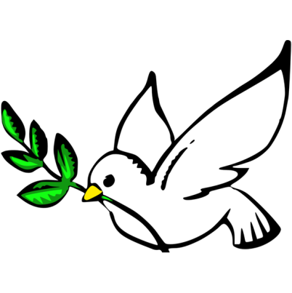
Until that day comes my friend,
Remain protected where you dwell,
And when this isolation passes,
May you be, fit, healthy and well.

Because the first Saturday in April,
Will come again next Spring,
And we wait in anticipation,
Knowing the joy that it will bring.
~Sharon Roche
The First Saturday in April 04-04-20

